13.3: The period is 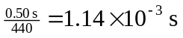 and the angular frequency is 